PHASE 2: Backend Development & Configuration

Activity 1 : Creation of Custom Table to Store Ticket Records.
Objective:
To create a custom table for storing and managing school IT ticket records.
Steps to Create Custom Table
- Open All menus → Search for Tables.
- Under System Definition → Click Tables.
- On the top right corner Click New button.
- Label : Incident WorkFlow.
- Uncheck the Create module.
- Now Save the Form.
- Then Click the Controls Suction and Enable the Check box true Auto Number.
- Now again save the Form.
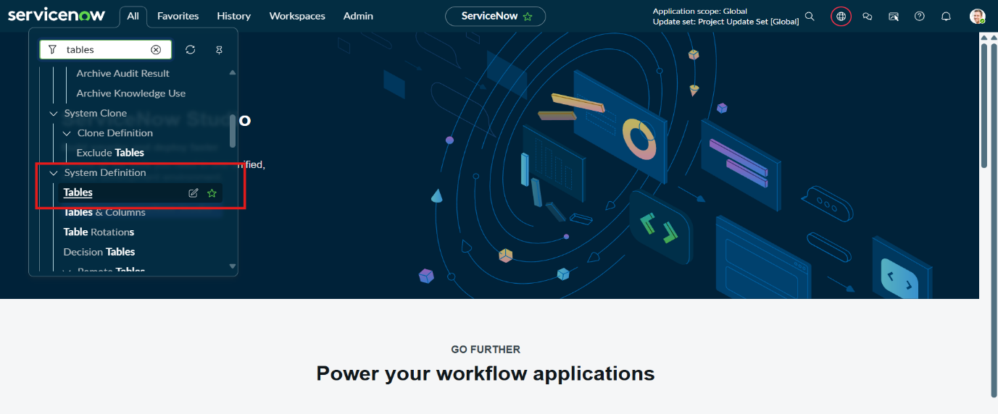

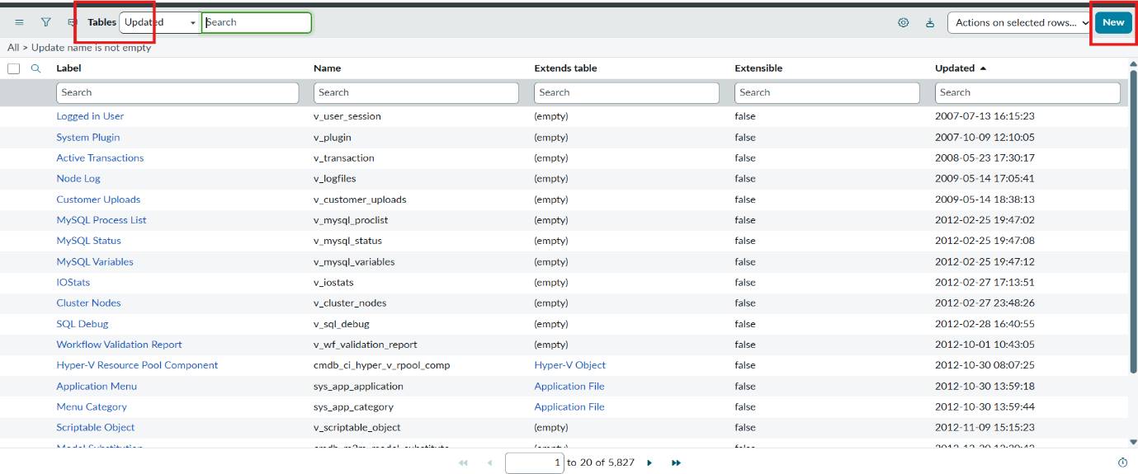
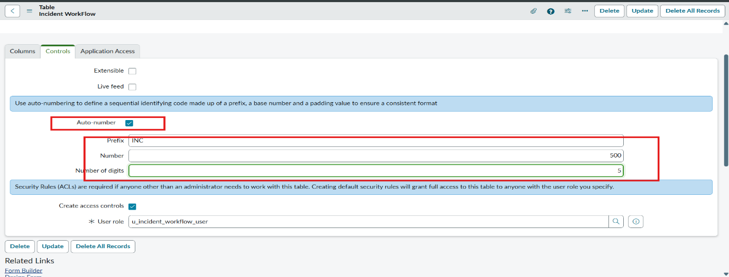
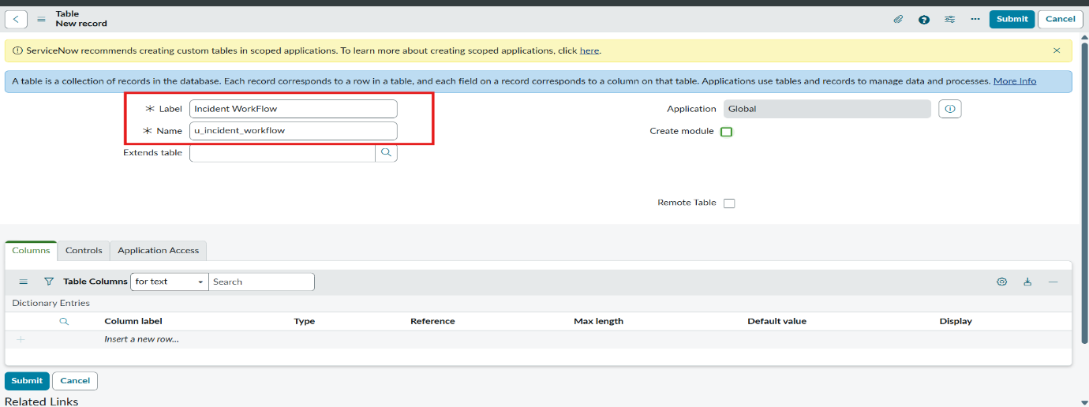

- Then Save the Form and Under Related Links Click Show Form.
- Now Open the Configure On clicking the Context Menu and then Open the Form Designer.
- Then Create Fields as Required.

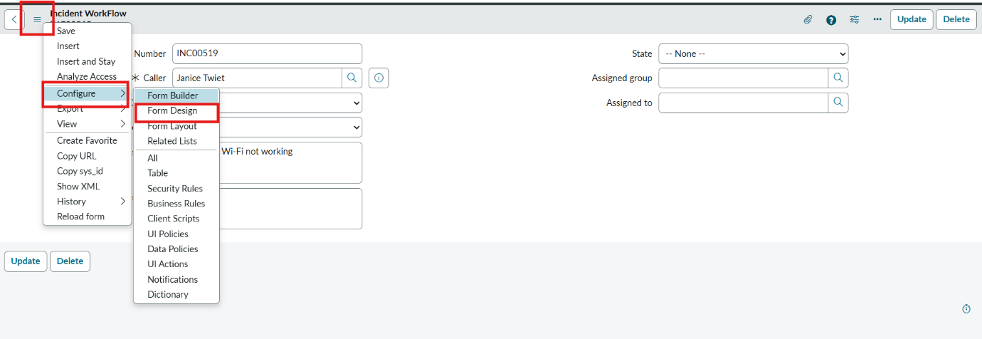
Activity 2: Field Creation and Data Type Configuration
The objective of this milestone is to create all required fields in the School IT Ticket table with correct data types, choices, and dependencies, ensuring structured and consistent data capture.
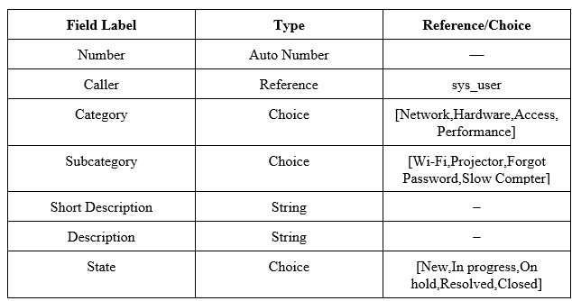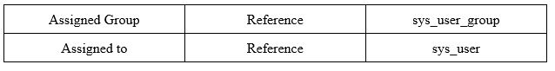

- After Creating Fields with their appropriate Type, then add the Choice from the Form design.
- To all the Choice list Fields.
- They are Category,Subcategory and State.

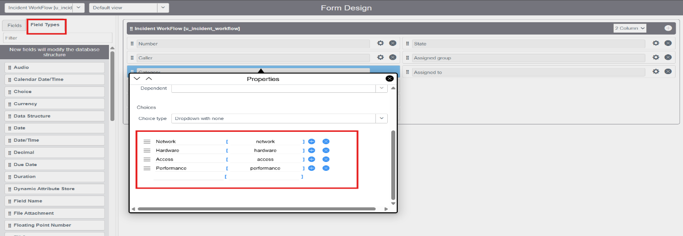
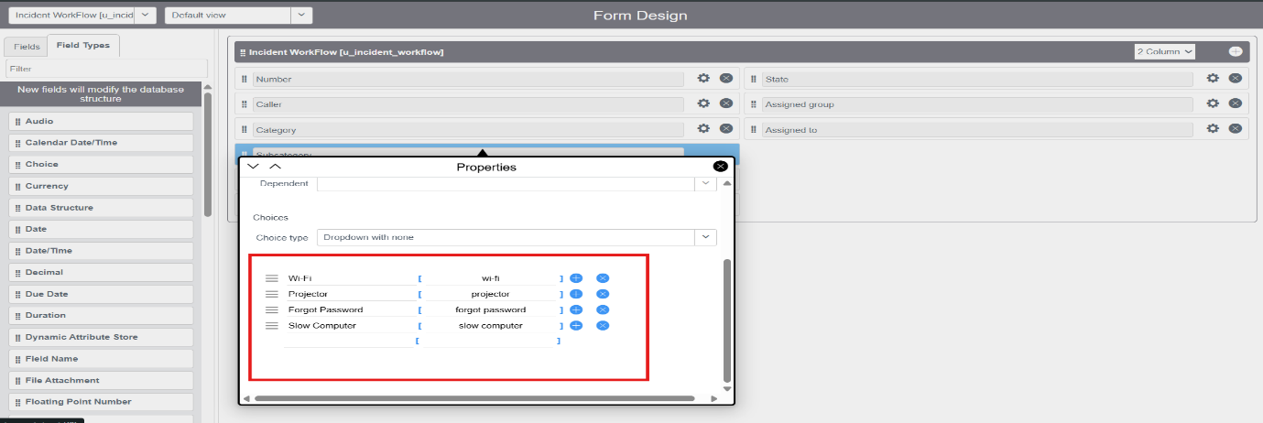

- Same like that, add Choice to the State field.
- Then Click the save button on the top right corner.
- Open the Form and reload it.

Activity 3 : Implementing Dependency Between Category and Subcategory Choice Fields

The objective of this milestone is to implement a dependency relationship between the Category and Subcategory fields so that the available Subcategory options dynamically change based on the selected Category.

Navigation Steps :
- Open the Created Table Form and Right click on the Subcategory Field.
- Click on the Configure Dictionary.
- Under Related links Click on the Advanced view,
- Then select the Dependent Field Section.
- Enable the checkbox Use dependent field true.
- Then select the Field Category on the Dependent on field.
- Then save the Form.

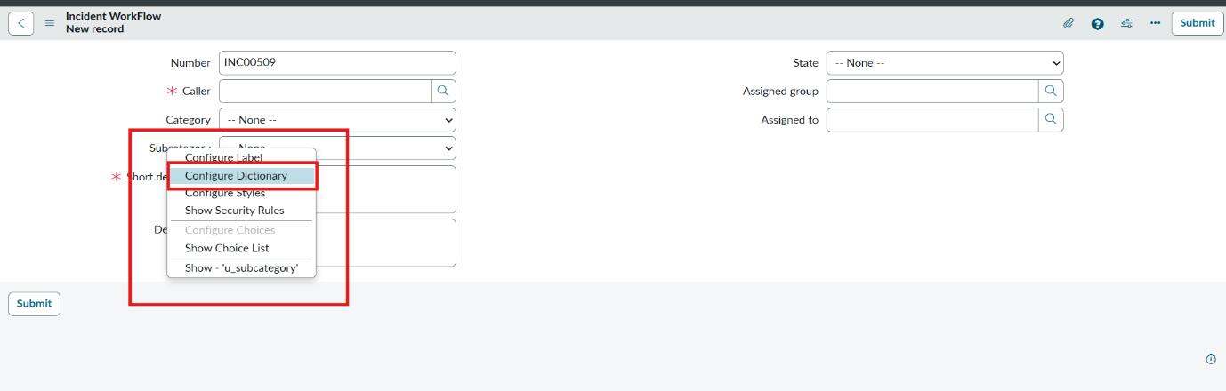
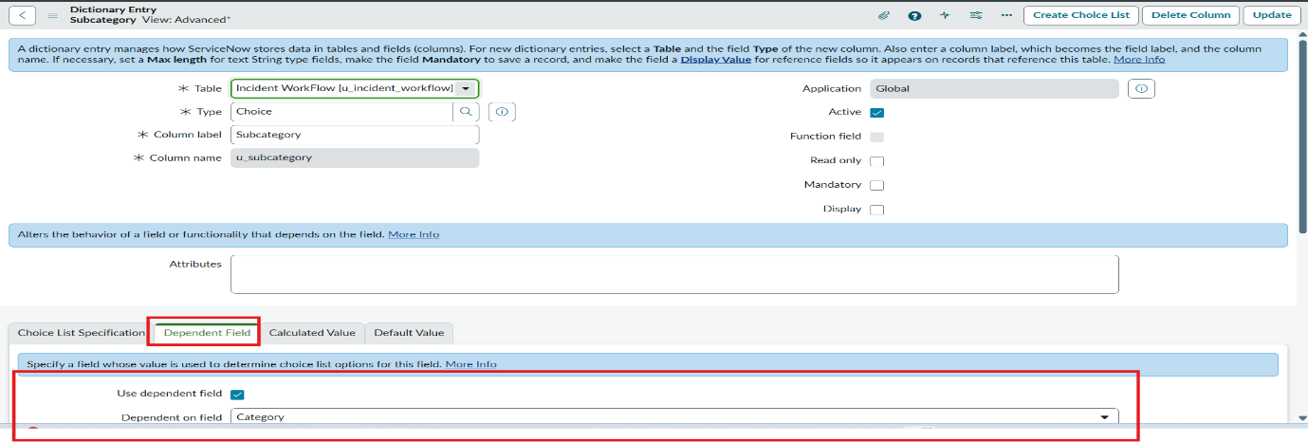

- Now scroll down to the choice section.
- Then add the dependent fields for which option dependent on the category gives the category choice backend name to the subcategory choice values.
- Wi-Fi → Network.
- Projector → Hardware.
- Forgot password → Access.
- Slow computer → Performance.
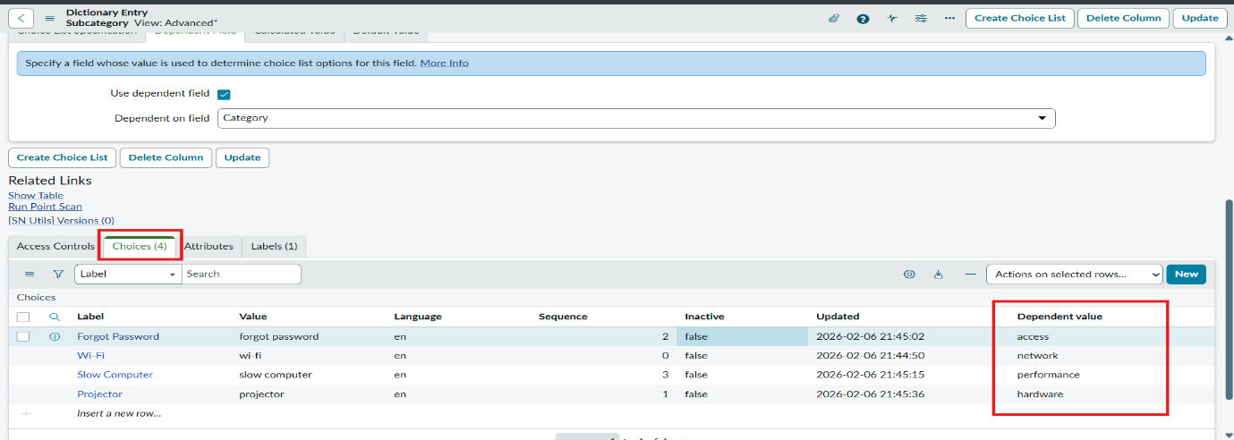

- Then save the Form.
- Then it will display each choice to each one separately based on the category subcategory displays.

